Come and join
Darwin Ward
and enjoy an evening of
70’s Music
Retro Buffet,
Table Quiz
and Raffle

Friday 5th October
7.30 pm
6 Sevenoaks Road
Orpington, BR6 9JJ

£12.50 per person
Payable in advance for catering purposes
Bring your own drink
Dressing up – optional!

“YOU EITHER LOVED THEM OR HATED THEM - BUT YOU’LL NEVER FORGET THEM!!”

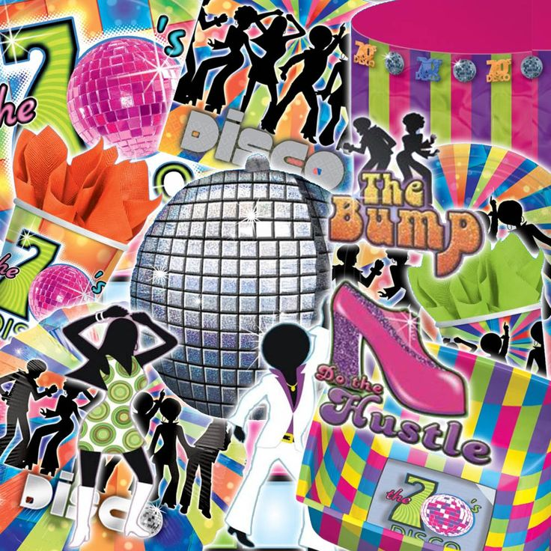

…………………………………………………………………………………………………………………………………………..………………………………………………
Please return to: Orpington Conservative Association, 6 Sevenoaks Road, Orpington, BR6 9JJ

PAY BY CHEQUE: I enclose a cheque for £…………… for places @ £12.50 each made payable to ‘OCA’ for the Darwin 70’s Night

PAY BY BACs: I have transferred £………..… on …..…../……..../2018 for places @ £12.50 each to
Sort Code: 60-16-03 Account No: 73536164 with ‘70s Night’ as the reference

Name:……………………………………………………………………………………….. Phone:………………………………………………………………………………………………………….
Address: ………………………………………………………………………………………………………………………………………………………………………………………………………………
……………………………………………………………………………………………………………………………………………………………………………………………………………………………..
Email: ……………………………………………………………………………………………………………………………………………………………………………………………………………………

Printed & promoted by Tony Owen on behalf of Orpington Conservative Association, both at 6 Sevenoaks Road, Orpington BR6 9JJ
European Union’s General Data Protection Regulation (GDPR)
The information you provide will be used only by the Conservative Party, including its candidates, representatives and associations. We will not give information to anyone else and it will be easy to withdraw your consent at any time. We would like to keep in touch with you and send invitations to events and topical political insights. Please tick the relevant boxes to indicate how you would like to receive this.
Email □ Phone □ Post □

